KaiKo

Use-Case Specification

Version <2.0>

Revision History
Date | Version | Description | Author
15/05/2026 | 1.0 | PA2: 8 use cases (UC01-UC08) | Group 9 - KaiKo
04/06/2026 | 2.0 | PA3: Added UC09 (Spectate), UC10 (Achievement & Store); updated UC03 (tier-based matching), UC04 (ArgKP + text debate, model fallback), UC06 (Gemini 2.5 Flash, PostgreSQL). | Group 9 - KaiKo

Table of Contents
1. Use-case Model 4
2. Use-case Specifications 4
2.1 Use-case: Login/Register Account 4
2.2 Use-case: Find-Match (Quick Match) 5
2.3 Use-case: Video Debate 6
2.4 Use-case: View Scoreboard and Post-match Analysis 6
2.5 Use-case: Text Debate 1v1 (Text Debate) 7
2.6 Use-case: View Match History and Dashboard 8
2.7 Use-case : Spectate Live Debate 8
2.8 Use-case: Achievement System and Store 9

Use-case Model
[Use-case diagram below: actors (Quản trị viên, Player) and all use-cases with include/extend relationships]

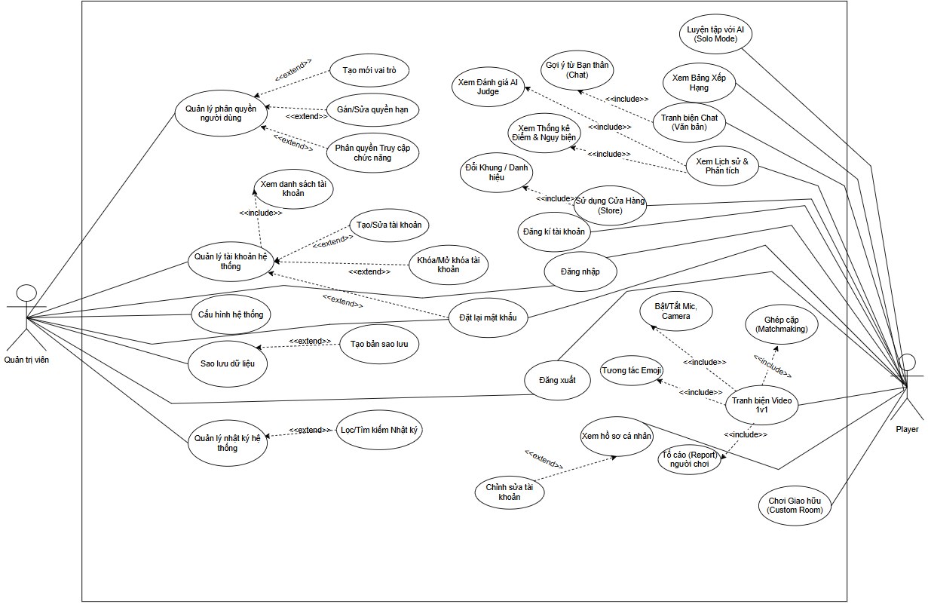
Figure 1 KaiKo Use-case Diagram
Actors:
• Guest: Unauthenticated – can view homepage, login, register.
• Player: Authenticated – full access to debates, history, store, events, friends, spectate.

Use-case Specifications

Use-case: Login/Register Account
Use Case Name | Login / Register Account
Use Case ID | UC01
Actor(s) | Guest (unauthenticated user)
Pre-conditions | The system is accessible via Chrome >= 100 or Edge >= 100.
Post-conditions | User is authenticated. Username stored in localStorage. Redirected to Dashboard.
Basic Flow | 1. Guest opens KaiKo in the browser.  2. System displays the HomePage with a 'Login' button.  3. Guest clicks 'Login' -> System displays AuthPage (username/password form or Google OAuth).  4. Guest enters credentials and clicks 'Login'.  5. System sends POST /login; backend validates credentials in PostgreSQL (SHA-256 hash).  6. Success: System stores username in localStorage and redirects to Dashboard.
Alternative Flows | AF1: Invalid credentials (Step 5)  Backend returns HTTP 401.  System displays: 'Incorrect username or password.'  Return to Step 3.
AF2: Register new account (Step 3)
Guest clicks the 'Register' tab.
Fills in username + password (>= 6 characters).
System checks username uniqueness -> if valid: creates account, SHA-256 hash, stores in PostgreSQL.
Redirects to login screen.
AF3: Google OAuth login (Clerk)
Guest clicks 'Sign in with Google'.
Clerk redirects to Google OAuth.
After authentication: Clerk returns session, system stores username, redirects to Dashboard.

Use-case: Find-Match (Quick Match)
Use Case Name | Find Match (Matchmaking 1v1 Video)
Use Case ID | UC03
Actor(s) | Player (authenticated user)
Pre-conditions | Player is logged in.  Browser supports WebRTC (Chrome >= 100 or Edge >= 100).  Camera and microphone can be granted.
Post-conditions | Two Players are paired in the same room. Both are redirected to DebateRoom with the same topic.
Basic Flow | 1. Player goes to ModeSelector and selects 'Video 1v1'.  2. System connects WebSocket /ws/{client_id}.  3. System sends { type: 'find_match', player_name, mode: '1v1' }.  4. Backend ConnectionManager adds Player to queue; applies tier-based matching (level difference <= 10).  5. A suitable opponent is found: Backend creates room, fetches topic from /random-topic, sends { type: 'matched', room_id, opponent, topic } to both.  6. Both frontends receive 'matched' and redirect to DebateRoom.  7. DebateRoom establishes WebRTC P2P via Firebase signaling (offer/answer/ICE).
Alternative Flows | AF1: No opponent found within 30 seconds (Step 4)  Timeout: Backend matches with any waiting player regardless of level.  If no one is waiting: system suggests switching to Solo vs AI.
AF2: WebSocket connection error (Step 2)
System displays: 'Cannot connect to server. Please try again.'
Player can click Retry.
AF3: Player exits while waiting (Step 4)
Backend detects WebSocket disconnect, removes Player from queue.

Use-case: Video Debate
Use Case Name | Conduct Video Debate (Video Debate)
Use Case ID | UC04
Actor(s) | Player A (current speaker), Player B (listener / waiting)
Pre-conditions | Both Players have been matched (UC03 complete).  WebRTC P2P connection established. Camera and microphone granted.
Post-conditions | Debate ends (all turns complete or a Player surrenders). Full transcript saved. System redirects to Scoreboard (UC06).
Basic Flow | 1. DebateRoom loads: both video streams appear via WebRTC.  2. System displays the debate topic.  3. Turn 1 starts: Player A is the active speaker (turn timer: configurable, typically 60-90 seconds).  4. Player A speaks. Web Speech API (lang='vi-VN') converts speech to text in real time.  5. Each sentence is sent to POST /analyze -> XLM-RoBERTa detects fallacy.  6. If fallacy detected (confidence >= threshold): FallacyAlert popup appears; score deducted.  7. MediaPipe FaceMesh analyzes eye contact and facial expression; Web Audio API monitors volume and pitch variance.  8. Turn ends: System saves Player A's turn transcript.  9. Switches to Player B's turn. Repeat Steps 4-8.  10. All turns complete -> proceed to Scoreboard (UC06).
Alternative Flows | AF1: Fallacy detected (Step 5)  /analyze returns label (one of 13 types) + confidence.  If confidence >= threshold and label != 'fallacy of logic': FallacyAlert shown for 4 seconds.  Score deducted automatically; fallacy logged in fallacies_list.
AF2: Player disconnects mid-debate (any step)
WebSocket drops.
System notifies remaining player: 'Opponent disconnected.'
Redirect to Scoreboard with partial result.
AF3: Player surrenders (any time)
Player clicks 'End Debate'.
System marks opponent as winner by default.
Redirect to Scoreboard.
AF4: Model not loaded (Step 5)
model_loaded = false: Backend uses Gemini API as fallback for fallacy detection.
Returns result normally to frontend.

Use-case: View Scoreboard and Post-match Analysis
Use Case Name | View Scoreboard and Post-match Analysis
Use Case ID | UC06
Actor(s) | Player A, Player B (both, after match ends)
Pre-conditions | All turns completed or a Player surrendered.  Full transcripts and behavioral scores (MediaPipe, Audio) compiled.
Post-conditions | Both Players see scores, fallacy list, and Gemini AI comments. Match result saved to PostgreSQL (match_history).
Basic Flow | 1. Frontend compiles DebateResult: topic, transcripts, fallacies_list, video/audio scores.  2. Frontend sends POST /score.  3. Backend compresses transcript (utils_preprocess.py), checks SemanticCache.  4. Cache miss: Backend calls Gemini 2.5 Flash API with compressed transcripts and rubric prompt.  5. Gemini returns structured JSON: scores for 4 criteria (logic, deductions, etc.), overall comment, winner declaration.  6. Backend adds MediaPipe/Audio scores and returns final JSON to frontend.  7. Frontend renders Scoreboard: win/loss/draw, score breakdown, detected fallacy list, AI comment.  8. Frontend sends POST /save-match -> saves to PostgreSQL match_history.  9. Player clicks 'Play Again' or 'Back to Dashboard'.
Alternative Flows | AF1: Gemini API quota exceeded (Step 4)  Backend uses compute_local_scores() for rule-based scoring.  Scoreboard displays with note: 'AI Judge unavailable - scores calculated automatically'.
AF2: Cache hit (Step 3)
SemanticCache finds similar result (cosine >= 0.90).
Backend returns cached result immediately (0 API calls).
AF3: POST /save-match fails (Step 8)
System logs the error but does not interrupt the Scoreboard view.
Scoreboard displayed normally.

Use-case: Text Debate 1v1 (Text Debate)

Use Case Name | Text Debate 1v1 (Text Debate)
Use Case ID | UC07
Actor(s) | Player A, Player B
Pre-conditions | Both Players have been matched (mode 'text_1v1').  No camera or microphone required.
Post-conditions | Text debate complete. Scoreboard displayed. Result saved to PostgreSQL.
Basic Flow | 1. Player selects 'Text 1v1' from ModeSelector.  2. System applies tier-based matchmaking (same as UC03).  3. TextDebateRoom loads: alternating chat interface.  4. Turn 1: Player A types their argument and clicks 'Submit'.  5. Backend calls POST /analyze-text: fallacy detection (XLM-RoBERTa) + ArgKP matching.  6. Results displayed inline: suspicious text flagged if fallacy detected.  7. Player B's turn. Repeat Steps 4-6.  8. All turns complete -> proceed to Scoreboard (UC06).
Alternative Flows | AF1: Solo vs AI (text mode)  No opponent needed: AI (Gemini) responds each turn via /generate-response.  AI responds as a real debater would.
AF2: ArgKP Matching returns 0 (argument off-topic)
System warns Player: 'Your argument does not appear related to the topic.'
Player can revise and resubmit.

Use-case: View Match History and Dashboard
Use Case Name | View Match History and Dashboard
Use Case ID | UC08
Actor(s) | Player (authenticated user)
Pre-conditions | Player is logged in.
Post-conditions | Player can view personal statistics, match history, leaderboard, and social features.
Basic Flow | 1. Player enters Dashboard after login.  2. Frontend sends GET /history/{username} -> retrieves last 20 matches from PostgreSQL.  3. Frontend sends GET /leaderboard -> retrieves top 10 users by level.  4. Dashboard renders 8 tabs: Home (stats, daily check-in, events), History (match log), Leaderboard, Friends, Store, Community, Live (spectate), Settings.  5. Player clicks each tab to view corresponding content.
Alternative Flows | AF1: No match history (Step 2)  Backend returns empty list.  Dashboard displays: 'You have no matches yet. Start playing!'  Prominent 'Play Now' button shown.
AF2: User not logged in (Step 1)
localStorage has no username.
Frontend redirects to AuthPage.

Use-case : Spectate Live Debate
Use Case Name | Spectate Live Debate
Use Case ID | UC09
Actor(s) | Player (spectator role)
Pre-conditions | Player is logged in.  At least one public room is currently active.
Post-conditions | Player can watch an ongoing debate in real time (read-only, no camera/mic needed).
Basic Flow | 1. Player goes to the 'Live' tab in Dashboard.  2. System displays a list of active public rooms.  3. Player clicks 'Watch' on a room.  4. Frontend sends { type: 'spectate', room_id } via WebSocket.  5. Backend adds Player to spectators[room_id].  6. Player receives real-time transcript and match state updates.  7. Player can leave at any time.
Alternative Flows | AF1: Room ends while spectating (any step)  Backend sends { type: 'debate_ended' } to all spectators.  System shows Scoreboard; spectator can return to Dashboard.

Use-case: Achievement System and Store
Use Case Name | Achievement System and Store
Use Case ID | UC10
Actor(s) | Player (authenticated user)
Pre-conditions | Player is logged in and has played at least one match.
Post-conditions | Player unlocks a new achievement OR successfully purchases/fails to purchase a store item.
Basic Flow | 1. System automatically checks achievements after each match (at end of POST /save-match).  2. If Player meets conditions: Backend updates user_achievements, sends notification.  3. Player goes to 'Store' tab in Dashboard.  4. System displays item list (avatar frames, badges, nickname cards) with prices in Store Points.  5. Player selects an item and clicks 'Buy'.  6. Backend checks store_points >= price -> deducts points, adds to user_items, returns success.  7. Player sees the item in their collection.
Alternative Flows | AF1: Insufficient Store Points (Step 6)  Backend returns HTTP 400: 'Not enough Store Points.'  System suggests playing more matches to earn points.

